February 12 – February 16
Important Dates
February 12th- Girls on the Run 2:30-3:45 (pick-up in the back)

February 13th- Garden Club 2:45-3:30

February 13th- PTO Bo-Night @ Bojangles 5:00- 8:00

February 14th- Valentine’s Day Parties 1:30

February 14th- Drama Club 2:45-3:30

February 16th- Math Explorers 7:05-7:30

February 16th- Good News Club 2:30-4:00 (pick-up in the back)

February 20th- Fun Run YMCA McMillian Park 3:30-4:30

February 21st- Drama Club 2:45-3:30

February 22nd- Third Grade Program 8:30

  - Mrs. Alencar | Mrs. Blanton | Ms. Cox | Ms. Fowler | Ms. White | Mrs. Wright

GRADE tHREE gazette

Learning in Third Grade:

Reading: Historical Fiction
Writing: TDA Practice
Language: Types of Sentences
Science: Fossils
Social Studies: Slavery
Math: Equivalent fractions

Spelling Words
1. berries 2. hobbies 3. puppies 4. bunnies
5. guppies 6. babies 7. ponies 8. countries
9. butterflies 10. families 11. arch 12. authentic
13. clarify 14. declare 15. grant

Extra Credit:

16. Valentine
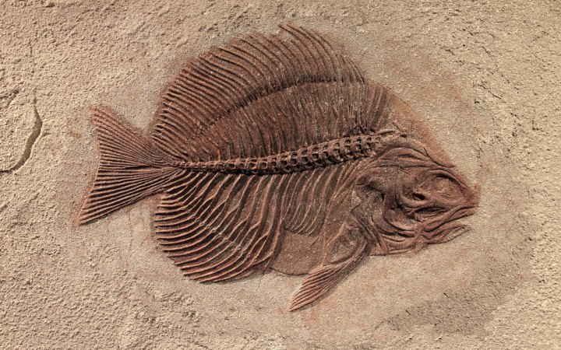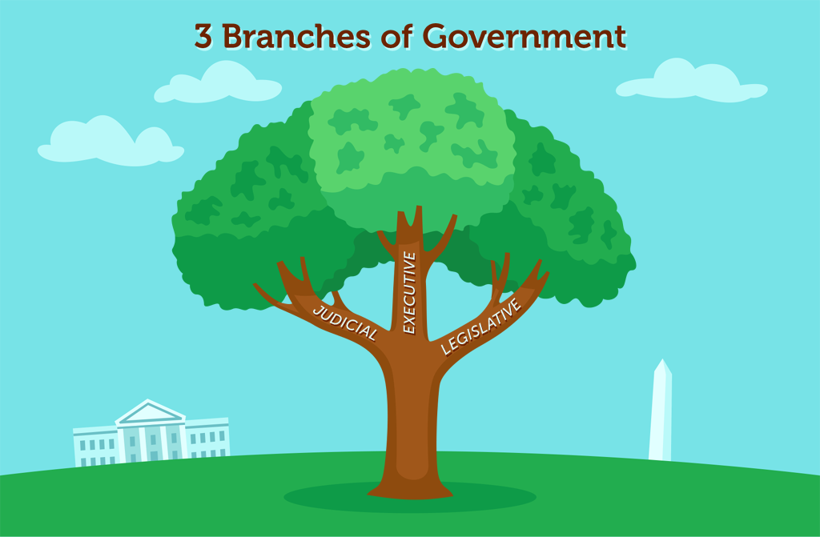

17. Gullah

18. Fossil

19. Equivalent

20. Prehistoric

Vocabulary Words (Unit 11)

arch: a curved structure that serves as an opening and as a support
authentic: being the real thing; worthy of belief, true
clarify: to say clearly or make easier to understand
declare: to state strongly; to make a formal or an official statement
grant: to permit or allow; to admit that something is true
grave: a hole in the ground where something is buried
modest: not thinking too highly of oneself, not boastful; proper in speech, dress, or behavior; not extreme or large
opponent: someone who is set against another, as in a contest, game, argument, or fight
valid: supported by facts or evidence, true
yearn: to long for

